Rezatec’s new Dam Monitoring geospatial AI platform drives dam safety to next level

With dam record and risk management, boosted by satellite ground motion, seepage and downstream hazard monitoring, AI and visualization features, Rezatec’s new platform helps create the most comprehensive, dynamic risk assessments.
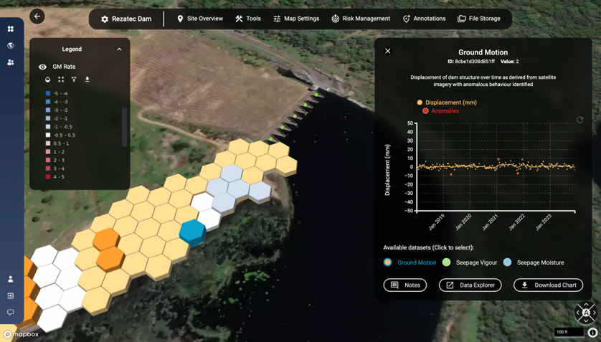

LONDON, September 16, 2024 – Rezatec has launched its enhanced Dam Monitoring solution, powered by its new geospatial AI platform. The new Dam Monitoring release enables centralized dam record management by digitizing and storing all dam information in one place and enhances it with satellite data and analysis for tracking unusual changes in ground movement, seepage, vegetation and downstream hazards.

Featuring the most advanced AI and visualization engine on the market, the solution analyses data and highlights potential issues on, around and downstream of the dam structure. This underpins potential failure mode monitoring and provides a unique risk management tool that drives existing dam and reservoir safety to the next level.

WATCH THE STORY BEHIND THE RELEASE

“As dam operators and regulators seek to improve their risk-informed decision making, it’s vital that they consider every aspect of data to identify and prioritize risks and develop mitigation measures,” says Camilla Braithwaite, Head of Product at Rezatec.

“This new Dam Monitoring solution, powered by Rezatec’s geospatial AI platform, leverages the most comprehensive and robust data sets combined with world-leading AI models and visualizations, to help dam operators and regulators determine, assess and dynamically manage exact risk areas on and around the dam.”

The new Dam Monitoring release combines four core modules:
*Compliance: Creates a centralized dam record by digitizing and storing all dam information in one place and applies powerful analytics and visualization to all rainfall measurement, instrumentation, water level, geo technical and level survey data. Enables easy dam record management and regulatory reporting.

*Ground Motion & Seepage: Uses satellite data and AI to remotely determine unusual changes in ground movement, seepage and vegetation mapped onto the structure. Year-round monitoring across the entire dam fills data gaps between manual inspections or in between sensor sites, and millimetric change alerts provide early warning on potential issues. Combines with dam record data to boost risk informed decision making and enable targeted ground resources.

*Downstream Hazard: Identifies the building changes in dam flood zones that have the potential to change hazard ratings across entire dam portfolios state-wide. Reduces the manual burden involved in collecting this information, enables targeted risk identification and supports emergency action planning.
*Risk Management: A unique risk matrix represents likelihood and consequence of failure metrics for each of the potential failure modes for a dam. Enables dynamic, comprehensive risk management.

Dam Monitoring customer Daniel Turnbull, Dam Safety Engineer, Hunter Water adds, “Rezatec are continuously improving this solution, and I’m impressed with these latest enhancements which are driving us in the way we use data and what to focus on. At Hunter Water we are confident we are doing everything in our power to exceed regulatory requirements and safeguard our dams and the surrounding population.”

“Rezatec’s new geospatial AI platform puts complex data science into the hands of dam operators and regulators by efficiently processing terabytes of satellite and unstructured data and featuring additional new tools including change alerts, 3D mapping, cluster analysis, benchmarking and reporting. Its powerful insights are easy to access and straightforward to use, providing a systematic catalyst for assessing the safety of dams, reservoirs and levees,” concludes Camilla.

—ends—
www.rezatec.com

Media contact:
Gill Hawkins
Marketing Director
gill.hawkins@rezatec.com

About Rezatec​
For nearly a decade Rezatec has pioneered geospatial analytics to help water leaders across the world manage the integrity of their assets with new insights. Today, we enable dam owners, operators and regulators to manage and report on risk, prioritize resources, and keep communities safe. And we bring next-level accuracy to water utility leaders, predicting the highest risk of pipeline failure across entire water networks, enabling them to upgrade infrastructure before breaks occur, cut water loss and repair costs, and justify capital expenditure with new conviction.

Our unique software products, powered by Rezatec’s leading geospatial AI platform, leverage the most comprehensive and robust data sets, combined with world-class AI models and visualizations, making complex data science easy to use.

